**How to Download a PDF from an email**

**to use in Microsoft Word for Immersive Reader**

Step 1 Scan hard copy through printer and send to your email

Step 2 Open up the document from your email in Adobe Acrobat

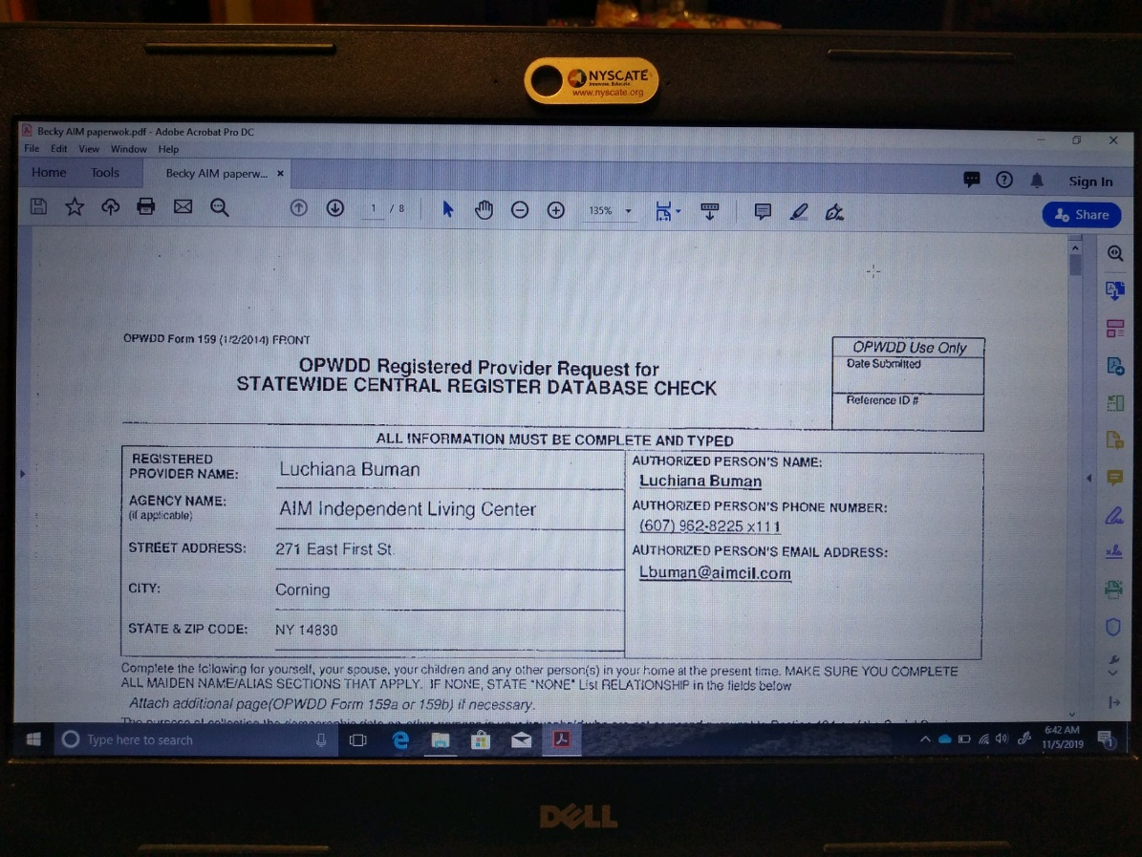

Step 3 Export PDF using the tools on the right hand side, 4th down

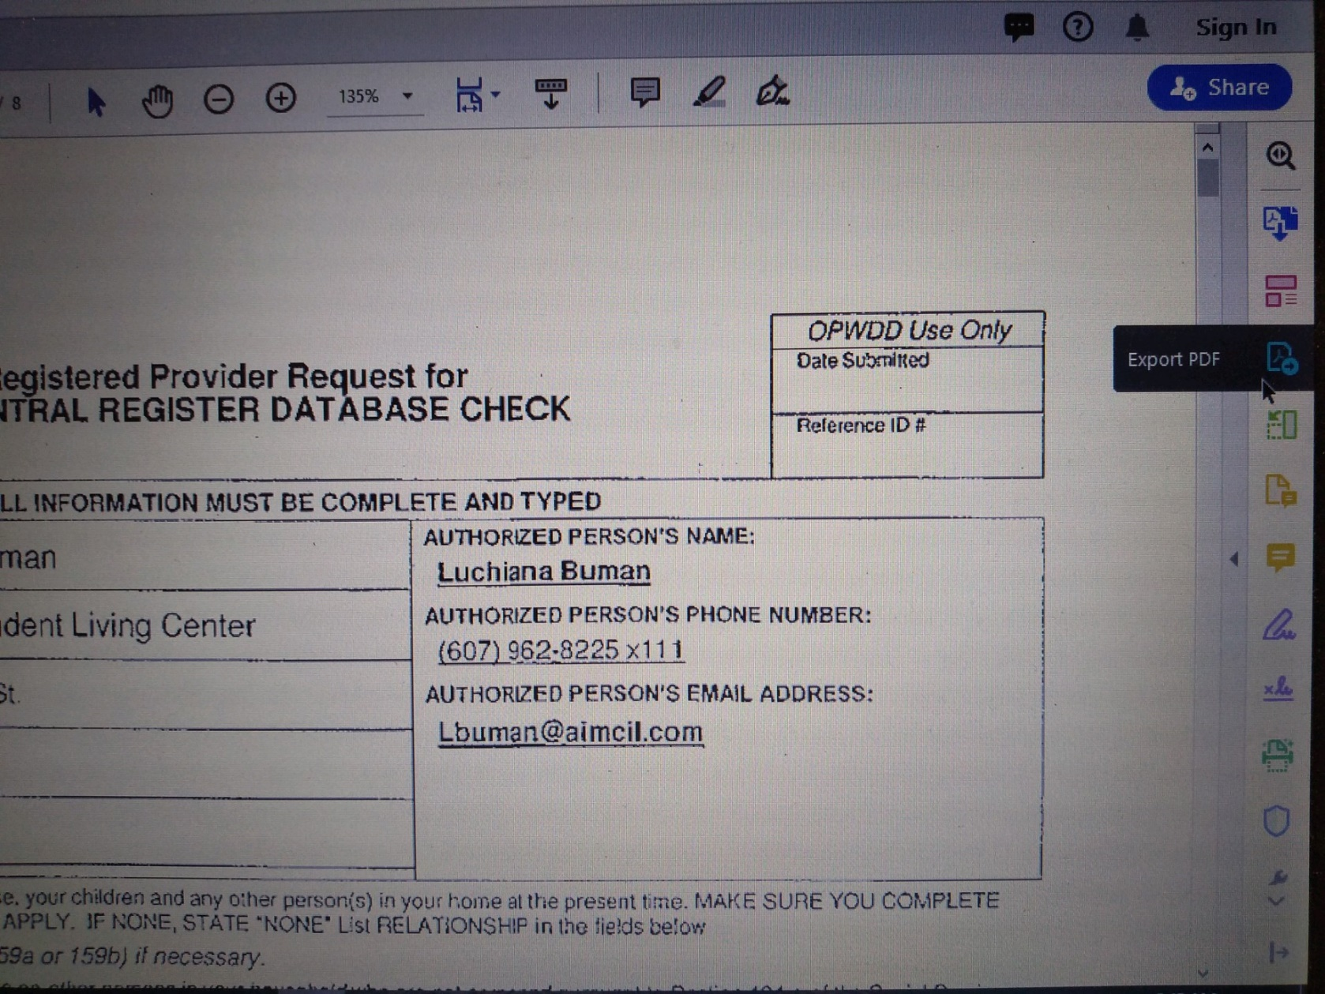

Step 4 Select Microsoft Word Format as the top selection and click

the **Blue** export at the bottom of the page

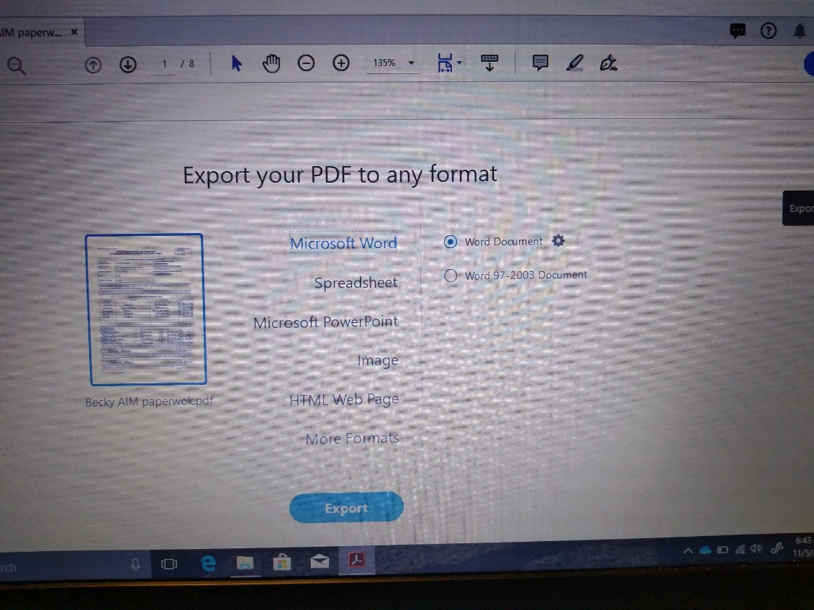

Step 5 Select location of where you want to store your file and rename

it if you choose

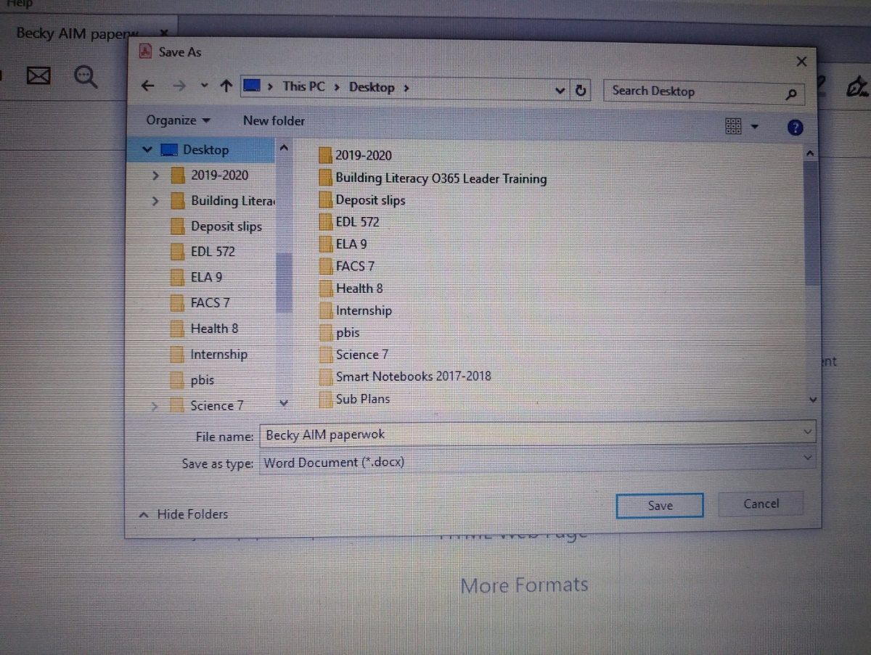

Step 6 Open up an email and send to yourself or another person to use

in Immersive Reader OR Use in One Note in Office365

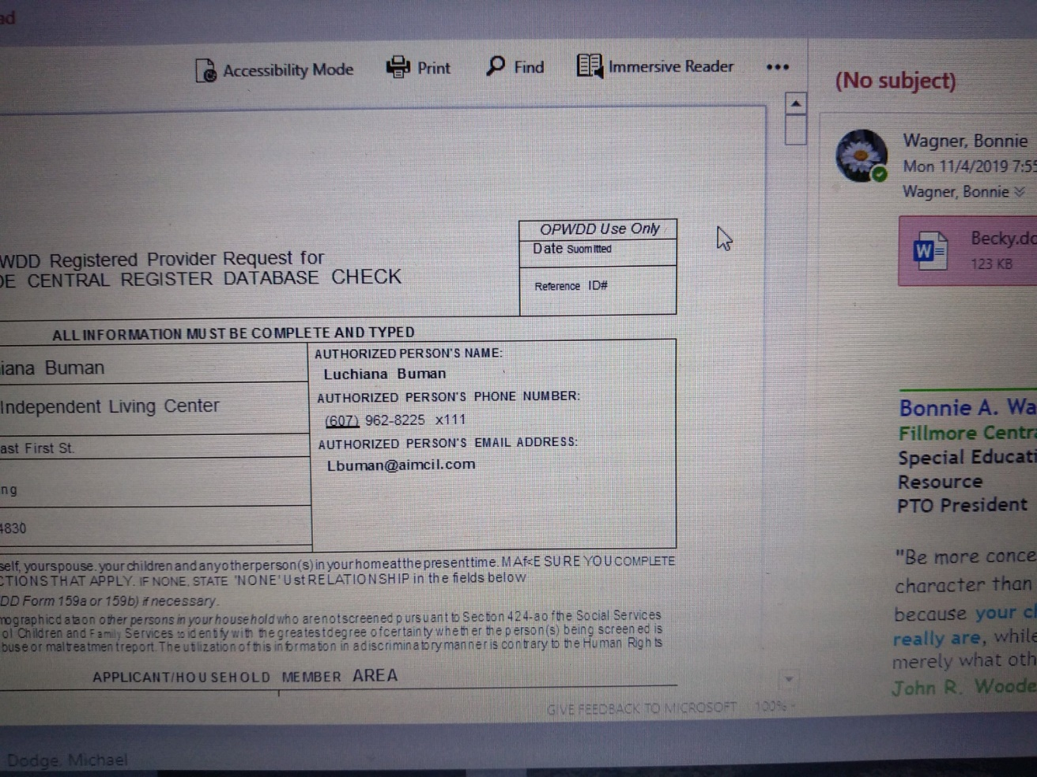

**To use just a Microsoft Word file Document**

**in Immersive Reader**

* start with Step 5 by selecting a word file already created or create a new one
* Then move to Step 6